THOMPSON MICHAEL OFFEI
INDEX NUMBER: 2672708
GROUP: X
MECHANICAL ENGINEERING II

KWAME NKRUMAH UNIVERSITY OF SCIENCE AND TECHNOLOGY.
MECHANICAL ENGINEERING LABORATORY

MECHANICS OF MACHINES LABORATORY
THE TORSIONAL PENDULUM EXPERIMENT


INTRODUCTION

A torsional pendulum consists of a wire or some other fibres. The pendulum oscillates by repeatedly twisting and untwisting about the axis through the centre of the wire. Though it is not strictly a pendulum since it does not oscillate because of the force of gravity, the mathematical formulas that describe the motion of a torsion pendulum are similar to the equations that describe the motion of a simple pendulum. The rods used in this particular experiment were brass and steel. The lengths and diameter of the two types of rod were varied and the time it took for each particular rod to make 20 complete oscillations was recorded. This experiment was to show that the period of the torsional pendulum depends on the moment of inertia, second moment of area and the shearing modulus.

OBJECTIVE: To study the behaviour of a torsional pendulum.
EQUIPMENT: A collet which can grip shafts of various diameters firmly is attached to a wall- bracket. The vertical shaft supports a large body of evolution by a similar collet at its lower end. This body can be made to oscillate torsionally.

DIAGRAM
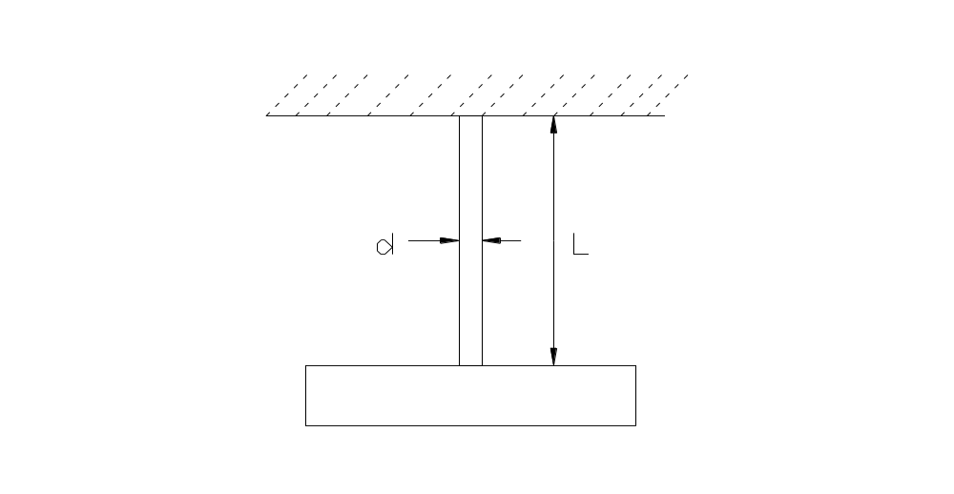
PROCEDURE
A shaft of either brass or mild steel is chosen. The length at which each oscillation would occur is marked using chalk or any other suitable material. After doing this, you pass the rod into the collet and using a key, close the collet to firmly grip the rod. Off set the rod and in a time of twenty seconds, measure the number of oscillations that occur. Repeat this for all the marked out lengths on the rod. Record you values and repeat the experiment for all the various diameters of the two types of rods. The tables below show the diameters of the rods, the lengths at which the oscillations were carried out and the various oscillations we had in t time of twenty seconds.

TABLE OF READINGS
VALUES FOR STEEL
 | 1 | 2 | 3
Diameter | 0.5cm | 1.25 cm | 1.5cm
Length | Time(s) | Time(s) | Time(s)
10 | 19 | 8 | 5.83
20 | 27 | 10 | 7.61
30 | 32 | 12 | 8.97
40 | 37 | 14 | 10
50 | 42 | 16 | 11

VALUES FOR BRASS
 | 1 | 2 | 3
Diameter | 0.5cm | 1.25cm | 1.5cm
Length | Time(s) | Time(s) | Time(s)
10 | 34.06 | 11.26 | 7.67
20 | 45.40 | 15.925 | 10.07
30 | 54.85 | 19.44 | 12.58
40 | 61 | 22.31 | 14.52
50 | 69 | 24.91 | 16.005

VALUES TO BE PLOTTED
VALUES FOR STEEL
STEEL ROD A |  | d = 0.32 CM
Length/m | t/s | T = t/20 | T^2/s^2
0.10 | 19.00 | 0.95 | 0.9025
0.20 | 27.00 | 1.35 | 1.8225
0.30 | 32.00 | 1.60 | 2.5600
0.40 | 37.00 | 1.85 | 3.4225
0.50 | 42.00 | 2.10 | 4.4100

STEEL ROD B |  | d =0.5 CM
Length/m | t/s | T = t/20 /s | T^2/s^2
0.10 | 8.00 | 0.40 | 0.16
0.20 | 10.00 | 0.50 | 0.25
0.30 | 12.00 | 0.60 | 0.36
0.40 | 14.00 | 0.70 | 0.49
0.50 | 16.00 | 0.80 | 0.64
STEEL ROD C |  | d = 0.6CM
Length/m | t/s | T = t/2 0/s | T^2/s^2
0.10 | 5.83 | 0.2915 | 0.0850
0.20 | 7.61 | 0.3805 | 0.1450
0.30 | 8.97 | 0.4485 | 0.2012
0.40 | 10.00 | 0.5000 | 0.2500
0.50 | 11.00 | 0.5500 | 0.3025
BRASS RODS
BRASS RODS A |  | d = 0.32CM
Length/m | t/s | T = t/20 /s | T^2/s^2
0.10 | 34.06 | 1.703 | 2.9002
0.20 | 45.40 | 2.270 | 5.1529
0.30 | 54.85 | 2.743 | 7.5240
0.40 | 61.00 | 3.050 | 9.3025
0.50 | 69.00 | 3.450 | 11.9025

BRASS RODS B |  | d = 0.50CM
Length/m | t/s | T = t/20 /s | T^2/s^2
0.10 | 11.26 | 0.568 | 0.3226
0.20 | 15.92 | 0.796 | 0.6336
0.30 | 19.44 | 0.972 | 0.9448
0.40 | 22.31 | 1.116 | 1.2455
0.50 | 24.91 | 1.246 | 1.5525

BRASS RODS C |  | d = 0.60CM
Length/m | t/s | T = t/20 /s | T^2/s^2
0.10 | 7.67 | 0.384 | 0.1475
0.20 | 10.07 | 0.504 | 0.2540
0.30 | 12.58 | 0.639 | 0.4083
0.40 | 14.52 | 0.726 | 0.5271
0.50 | 16.00 | 0.800 | 0.6400

GRAPHICAL REPRESENTATION OF RESULTS

GRAPH FOR STEEL ROD A
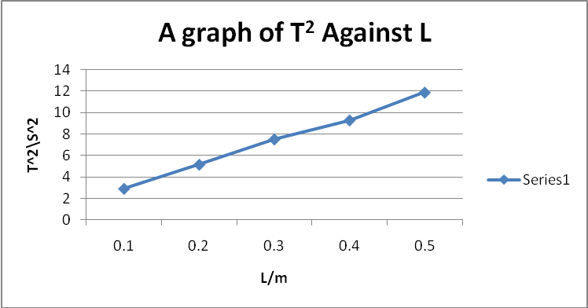
GRAPH FOR STEEL ROD B
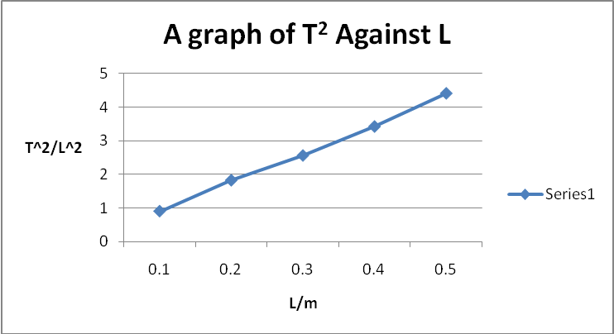

GRAPH FOR STEEL ROD C
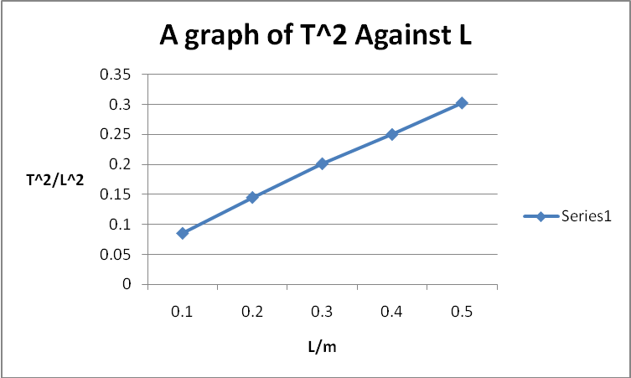
GRAPH FOR BRASS ROD A
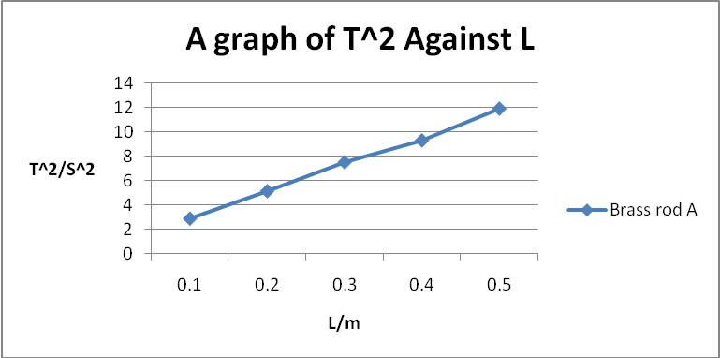

GRAPH FOR BRASS ROD B
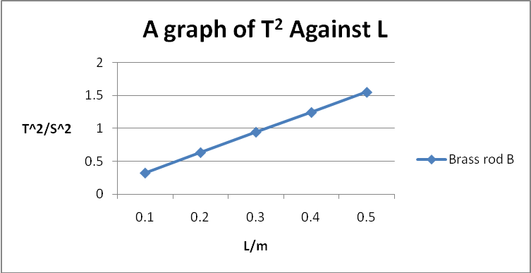
GRAPH FOR BRASS ROD C
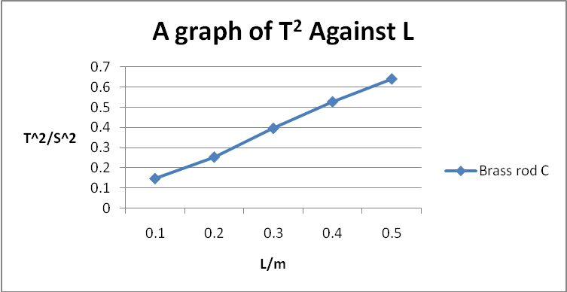

CALCULATIONS
From the first equation, it can be deduce that gradient 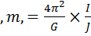
Making G the subject gives 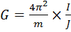
J is the second moment of area of the circular shafts, 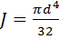
I is the moment inertia of disk 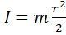
But, Mass of disc =24kg
Radius of disc=12.5cm
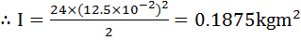

CALCULATIONS FOR THE THREE STEEL SHAFTS
For Steel rod A, d = 0.32cm=0.0032m
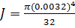
From the graph m=0.244
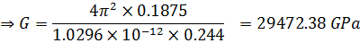
For Steel rod B, d = 0.5cm=0.005m
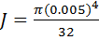
From the graph m=0.029
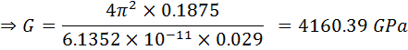
For Steel rod C, d = 0.600cm=0.00600m
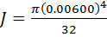
From the graph m=0.012

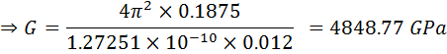

COMMENTS AND RECOMMENDATIONS
Sources of error
- Large amplitudes of oscillation
- Irregular motion during oscillation
Precautions taken
- Angular displacement θ of the material was small.
- The time was taken twice for 20 oscillations and the average time found.
- The shaft was firmly fit into the collets before setting into vibration.
- Shafts were prevented from swinging during oscillation.

From the results obtained, the period T is dependent on the length L and diameter d of the shaft used. As length L of shaft is increased the period T also increases, whiles as the diameter d of the shaft is increased the period T decreases. If the diameter d is decreased the period T increases.
Also from the experimental values obtained, the square of the period T can be plotted against length L of the shaft, to give a straight line. From this line the shear modulus G of the shaft material can be determined from its slope.
CONCLUSION
Experimental values not equal to theoretical values due to the following:
- Angle of twist θ of the shaft not uniform throughout the experiment.
Unbalance forces due to air resistance
- The shaft not perfectly straight.
- Lost of some of the shafts elasticity due to the years it has being used.

